Armourshield Instructions

Tips
Roof shingles should be fixed onto a wooden boarded roof.
It is a good idea to lay out the roof shingles on the floor first so you can understand the pattern before you start fixing them to the roof.
Start at the front of the roof and work to the back.
On hot days do not peel off the plastic on the back of the roof shingles until you are ready to lay them otherwise the shingle strips will stick together.
Complete one side of the roof before moving onto the other side and finally the ridge.
Keep hold of any offcuts until you have finished the roof because you may be able to use them elsewhere.
Remember to follow health and safety guidelines when fitting shingles. Lifting and carrying, sharp objects and working at height are all involved. It is your responsibility to use/fit the roof shingles in a correct and safe manner. We cannot be held responsible for any problems, damage or injury caused by your failure in respect to these matters.
When the roof is finished make sure you dispose of the wrappers, peel off strips and offcuts correctly.
The roof shingles should be fixed onto the roof using extra large headed clout nails
The length of the nail depends on the thickness of your roof boards. The nail will need to go through 2 layers of roof shingle (approximately 6mm in total) and a good way into the roof board. You may need a longer length for the ridge because you will going through more layers of shingles there.
The nails should be hammered so that they go in straight and sit flush with the top of the roof shingle surface. If they go in an angle or you hammer them down too far they will tear the surface of the roof shingle which in turn will allow water ingress.

1 - Open The Pack
The best way to open the packs of roof shingles without damaging the shingle strips inside is to take a work knife and run it around the sides of the pack.
You should then be able to lift up the top of the plastic (like a lid) and access the shingle strips.

2 - Starter Strip
The starter strip runs along the eaves edge of the roof.
Take a shingle strip and cut off the first hexagonal tab.
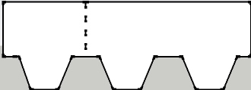
Next use a straight edge to cut off the hexgonal bottoms so you are left with a rectangular strip.
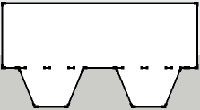
Start at the front and work to the back.
Take the rectangular strip you have made and peel off plastic on the back.
Fit the rectangular strip flush with the gable end of the building but leave it overlapping the eaves edge by approximately 2.5cm.
Fix the rectangular strip down with extra large headed clout nails.
Take the next shingle strip. This time you do not need to cut off the first hexagonal tab but you do need to cut off the hexagonal bottoms to leave you with a longer rectangular strip. Butt this strip up to the first one and fix it down.
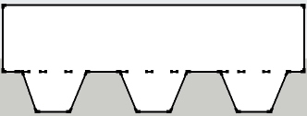
Complete the rest of the row in the same way.
When you get to the back there might be some of the strip overhanging the back of the roof. Cut this off with a work knife.

3 - First Row
Start at the front and work to the back
Take a shingle strip and keep the hexagonal bottoms facing towards the eaves edge.
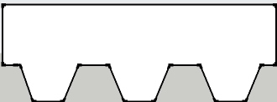
Position the shingle strip directly on top of the starter strip, again flush with the gable end but overlapping the eaves edge by approximately 2.5cm.
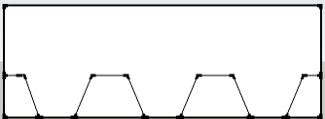
Peel off the plastic on the back and fix the shingle strip down with extra large headed clout nails as shown below. The nails at each end of the shingle strip need to be close to the edge to hold the strip down (it was a bit difficult to show it on this diagram).
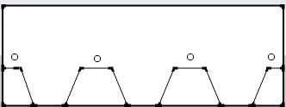
Take the next shingle strip, butt it up to the one you have just fixed down and nail it down too.
Complete the rest of the row in the same way.
When you get to the back there might be some of the strip overhanging the back of the roof. Cut this off with a work knife.
Keep hold of any offcuts in case you can re-use them elsewhere on the roof.

4 - Second Row
Take a shingle strip. Starting at the front, position the strip so that the hexagonal bottoms of the shingle strip you are holding fits up to the gap in the shingles you have fitted in the first row, see diagram below.
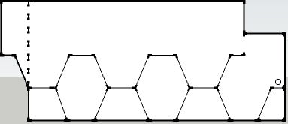
You should have covered the nails.
You will probably have some of the shingle strip overhanging the front of the roof. Cut this off with a work knife once you have fixed the strip down.
Fix the shingle strip down with nails in the positions shown below. Again the nails at the ends of the shingle strip need to be fixed down close to the edge but it was hard to show it so precise here.
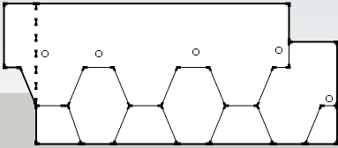
If you have positioned the shingle strips correctly then the nails you put in now should go through the current shingle strip and also the top edge of the shingle strip below. This means that each shingle strip is still held down by 8 nails as planned but it is a more economical way of doing it.
If you are using the 'Ultra' colours you will be able to see some of the black shadow band. This is correct.
DO NOT try to pull the shingle strip down further to hide the black shadow band. This is not correct and means the roof shingles will not cover as large an area as they are designed to so you are likley to run out.
Complete the rest of the row.
When you get to the back there might be some of the strip overhanging the back of the roof. Cut this off with a work knife.
Keep hold of any offcuts in case you can re-use them elsewhere on the roof.

5 - Completing The Main Roof
Do as many rows of roof shingles as you need to reach up to or just below the ridge.
Do the same steps on the other side of the roof.

6 - The Ridge
You should use roof shingles to cover the ridge of your apex roof.
Take a shingle strip and cut it into three separate sections.
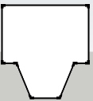
Starting at the front of the roof, take one section with the straight edged top facing the front of the ridge and the hexagonal bottom facing the back of the ridge.
Bend the section over the ridge and fix down on both sides of the ridge with extra large headed clout nails. The nails need to go close to the edge to hold the section down but it was hard to show this on the diagram below.
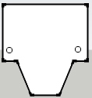
Take another section, place it overlapping the first one a little and fix down.
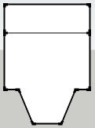
Work your way to the back of the ridge in the same way

7 - Felt Fillet
To finish off your roof at the gable ends it is a good idea to fit a felt fillet.
This is a length of timber which runs from the eaves edge up to the apex along the gable end. It is generally the same length as the fascia boards and can be fixed onto them to make it easier to fit.
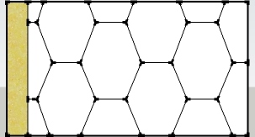
The felt fillet covers the ends of the roof shingles. It will help to protect the ends from wind and rain.

